LESSON PLAN
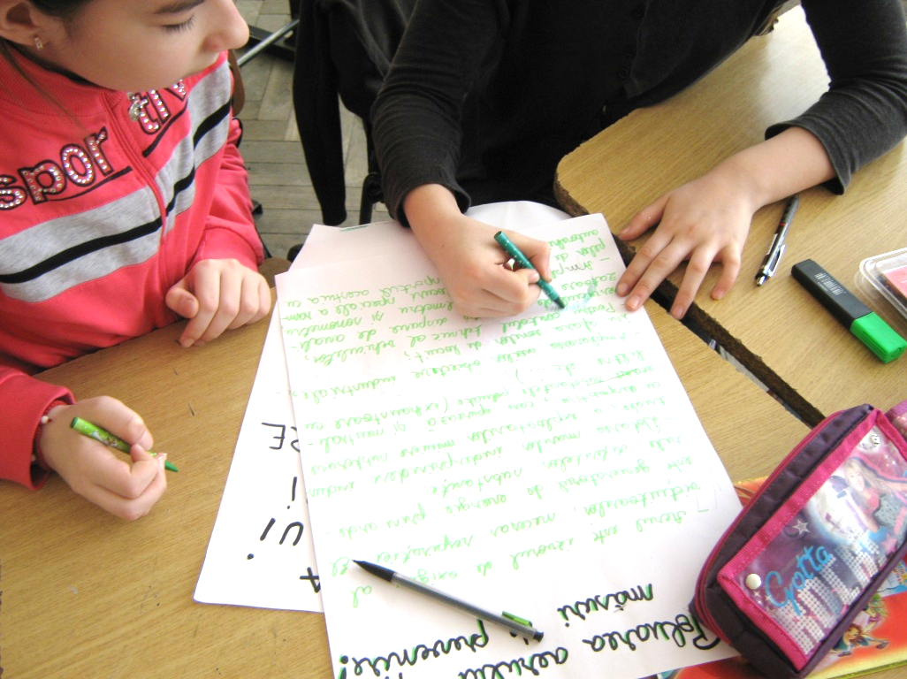
WATER AS LIFELINE FOR HUMANITY
FALL FOR WATER
2018-1-FR01-KA229-048322_3
Topic: Water as lifeline for humanity-Sustainable consumption of water
Time: 50’
Aims: raising awareness towards the most important environmental damage
made by man, raising awareness about the possibility of being able to take actions
on environmental protection and conservation – focusing on water
Students` age: 10-14
Aims:
1.2. to explain the differences between the conditions: healthy/physical
discomfort/illness;
2.2. to be able to take responsible and proper decisions when their health is threatened;
2.3. to develop healthy interpersonal and environmental relationships;
3.2. to be able to assess the short- and long-term effects of exposure to health risk;
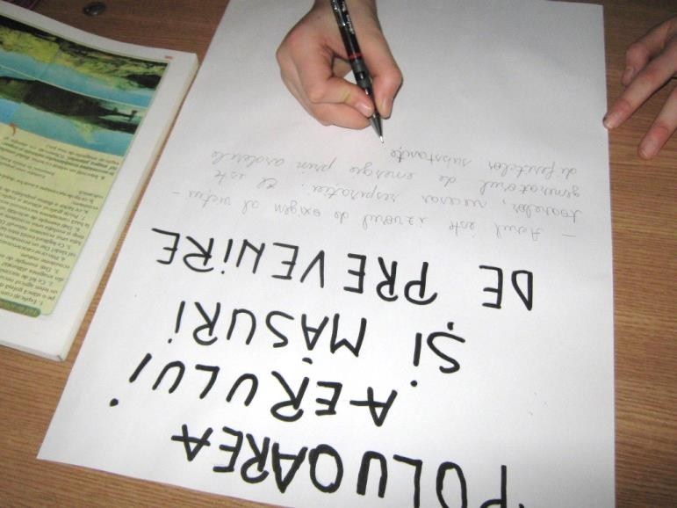
3.3. to get involved in properly sorting the household waste.
Operational objectives: At the end of the lesson students have to be able:
O1 – to describe the causes of air, water, soil pollution and the effects they have
upon the environment;
O2 – to identify the sources of pollution for air, water, soil;
O3 – to find ways of reusing and recycling materials;
O4 – to create their own plan concerning the ecological stability of their environment;
O5 – to approach these issues in a creative way;
Lesson type: Communication and acquisition of new knowledge
Didactical endeavor:
- Teaching techniques/methods: heuristic conversation, observation, explanation,
exercise, brainstorming, questioning, jugsaw
- Materials: handouts, evaluation papers, video and power point presentations,
computers connected to the internet, video projector
Class organization: individual work, pair work, group work, lockste

PROCEDURE

STAGES OF THE LESSON | TIME/  OBJECTIVES | TEACHER`S ACTIVITY | STUDENT`S ACTIVITY | METHODS  MATERIALS | INTERACTION | EVALUATION
Warm - up | 2` | T checks if everything and everybody is prepared for the lesson; jots down the absents; prepares the didactical material needed for the teaching activity. | Ss get ready for the lesson; they prepare their materials (book, notebook, pencil case etc) | Conversation | Lockstep
Review of past material | 5`  O1 | Orally addressed questions:  1.What does `POLLUTION` mean?  2.What does `POLLUTANT` mean?  3.What pollutants do you know?  4. What do the concepts `protecting` and `preserving` refer to? | Ss answer T`s questions:  -Pollution: the contamination of the environment with different substances (pollutants);  -Pollutants: material, chemical, biological;  - Pollutant: a substance that causes pollution;  Environmental protection: the legal activities that we undertake in order to protect the environment and the endangered species of plants and animals.  -Preserving the environment: rational and efficient use of the natural resources, adopting the most appropriate ways and technological operations/actions for limiting and preventing the harmful effects of some natural phenomenons. | Conversation | Lockstep | T supervises /supplies error correction, makes appreciations, checks the appropriate answers, praises the Ss who get actively involved in the activity, encourages all Ss to participate with opinions
Catching Ss` attention  Lead in  Introducing the new lesson | 5’  O1  O2 | T asks a S to read `The message of the Planet Earth`. (Annex 1)  -Children, would you like to help the Planet Earth?- the T asks.  The T explains to the Ss the fact that in order for us to be able to respond to our Earth`s shout for help, we first have to carefully analyze the causes of its destructions and then to find out solutions for stopping these harmful activities.  From the activity listed above, the Ss will acquire knowledge concerning the vital friendly relationship that has to occur between the environment and people.  The T writes the title of the lesson on the blackboard and elicits the objectives of the lesson.  Title: Sustainable consumption and production. | Ss listen carefully to the message read by their colleague and to the explanations provided by the teacher.  Ss jot down the title of the lesson and listen carefully to the T. | Conversation  Questioning | Lockstep | T supervises /supplies error correction, makes appreciations, checks the appropriate answers, praises the Ss who get actively involved in the activity, encourages all Ss to participate with opinions.
Conducting learning | 25’  O1  O2  O3  O4  O5 | For studying this main topic the T will use the Jigsaw method. This technique is a method of organizing classroom activity that makes Ss dependent on each other to succeed. It breaks classes into groups and breaks assignments into pieces that the group assembles to complete the jigsaw/puzzle.  I have chosen to use this method because as it is a cooperative learning technique it reduces conflicts among Ss, promotes better learning, improves Ss` motivation and increases enjoyment of the learning experience.  The Ss are grouped, each group has a distinct number and a different topic.  Group I  Learning task: Air pollution  Ss answer the questions:  What is the air?  What importance/role does it have?  Which are the polluting agents/the agents that cause damage to the environment?  What effects has the air pollution on the animals, plants, humans and any other way of existence?  Think of some actions of reducing/decreasing air pollution?  Group II  Learning task: Water pollution  Ss answer the questions:  What is water?  What importance/role does it have?  Which are the polluting agents/the agents that cause damage to the water?  What effects has the air pollution on the animals, plants, humans and any other way of existence?  Think of some actions of reducing/decreasing water pollution?  Group III  Learning task: Soil pollution  Ss answer the questions:  What is soil?  What importance/role does it have?  Which are the polluting agents/the agents that cause damage to the soil?  What effects has the soil pollution on the animals, plants, humans and any other way of existence?  Think of some actions of reducing/decreasing soil pollution?  Group IV  Learning task: Overexploitation of the natural resources  Questions:  Which are the effects of overexploitation on the animals, , plants, people?  What protection actions can you think of for preventing overexploitation?  What do the following word refer to:  - overexploitation  - deforestation  - overgrazing  - poaching  Group V  Learning task: Garbage and Recycling  Questions:  Name the following: garbage/waste and recycling;  Name some types of garbage/wastes;  Name some recycling materials.  From each group, a leader is chosen who will present the activity of the whole group.  The T brings extra information about pollution. She uses a PPT presentation:  - types of pollution: atmospheric, air, soil;  - types of pollutants;  - measures to prevent pollution;  - methods for preserving natural resources;  - waste/garbage recycling  The T also writes the lesson sketch on the blackboard. | The Ss provide answers to these questions on the basis of their general knowledge and everyday living.  Each S comes in front of the classroom and writes his/her answer on the flipchart.  All the Ss copy the answers onto their notebooks.  The Ss solve the tasks  They provide definitions for: air, water, soil; they also emphasize these elements` importance for life.  They identify the effects of pollution on animals, plants, humans and any other way of existence.  Ss give definitions for:  - overexploitation  - deforestation  - overgrazing  - poaching  They also identify:  - the causes which are in favor of /are fostering overexploitation;  - the effects of overexploitation on plants, animals, people.  Poaching: illegal hunting or fishing.  Ss solve the task providing definitions.  Types of waste: biodegradable and non biodegradable.  Recycling materials: plastic, glass, aluminum, paper, cardboard. | Conversation  Brainstorming  Discovery learning  Handouts  Handouts  Handouts  Handouts  Handouts | Group work  Group work  Group work  Group work  Group work | T supervises /supplies error correction, makes appreciations, checks the appropriate answers, praises the Ss who get actively involved in the activity, encourages all Ss to participate with opinions.  T asks Ss for questions, helps them understand new word/concepts.  T supervises /supplies error correction, makes appreciations, checks the appropriate answers, praises the Ss who get actively involved in the activity, encourages all Ss to participate with opinions.  T asks Ss for questions, helps them understand new word/concepts.  T supervises /supplies error correction, makes appreciations, checks the appropriate answers, praises the Ss who get actively involved in the activity, encourages all Ss to participate with opinions.  T asks Ss for questions, helps them understand new word/concepts.
Reinforcement activity | 10’  O1  O2  O3  O4  O5 | The T gives each S an evaluation handout, explains the task and asks Ss to solve it.  T conducts oral evaluation of the test. | Each S solves the task received from the T. | Exercise  Enouncement  Handout | Individual | T supervises /supplies error correction, makes appreciations, checks the appropriate answers, praises the Ss who get actively involved in the activity, encourages all Ss to participate with opinions.
Evaluation activity | 3’ | Homework:  You are members of the `Environmental Board`. You are highly responsible people. You have to devise and draw the city of the future (from out EU planet) which should be in perfect ecological shape/balance. While solving this task you should consider making green spaces, having drinkable water sources. Also, consider the issue of waste/garbage, types of industries, noise level etc; Your city should also display messages of sustainable consumption and production.  T praises the most active Ss and jots down appropriate marks | - Ss solve the task | Conversation | Paper sheets  Exhibition | Possible pair work or individual work – the Ss can choose

ANNEX 1

Dear children,
I am very sick.
More and more dangers threatens me every day.
My natural wealth are diffusing.
My animals are dying.
My plants and trees are disappearing.
Thea air layer that protects me from the powerful sunbeams is getting thinner and thinner.
I`m all covered in garbage.
Everything is so dirty around me!
Please, help me!
Love,
Your loving and life giving Earth.

Prietenul vostru,
Pământul

Student`s name: …………………………………………………………
Grade: ……………………………………………………………………
Date: ………………………………………………………………………

EVALUATION TEST

- Give examples of environmental degradation and water pollution from your home city.

- Name two polluting thing related to water that you consider to be the most harmful from your city.

- Identify an activity of overexploitation of resources in the area in which you live/your city.

HANDOUTS

Group I
Learning task: Air pollution
Ss answer the questions:

What is the air?

What importance/role does it have?

Which are the polluting agents/the agents that cause damage to the environment?

What effects has the air pollution on the animals, plants, humans and any other way of existence?

Think of some actions of reducing/decreasing air pollution?

Group II
Learning task: Water pollution
Ss answer the questions:

What is water?

What importance/role does it have?

Which are the polluting agents/the agents that cause damage to the water?

What effects has the air pollution on the animals, plants, humans and any other way of existence?

Think of some actions of reducing/decreasing water pollution?

Group III
Learning task: Soil pollution
Ss answer the questions:

What is soil?

What importance/role does it have?

Which are the polluting agents/the agents that cause damage to the soil?

What effects has the soil pollution on the animals, plants, humans and any other way of existence?

Think of some actions of reducing/decreasing soil pollution?

Group IV
Learning task: Overexploitation of the natural resources
Questions:

Which are the effects of overexploitation on the animals, , plants, people?

What protection actions can you think of for preventing overexploitation?

What do the following word refer to:
- overexploitation
- deforestation
- overgrazing
- poaching

Group V
Learning task: Garbage and Recycling
Questions:

Name the following: garbage/waste and recycling;

Name some types of garbage/wastes;

Name some recycling materials.

LESSON SCKETCH: SUSTAINABLE CONSUMPTION AND PRODUCTION

Sustainable consumption:
- help for the economic crisis;
- brought about by the intense industrial and resourceful exploitation and continuous degradation of the environment;
- focused over preserving the quality of the environment.

Practical aspects of a sustainable development:
- diminishing the consumption of materials and energy in civil engineering field;
- diminishing the quantities of waste coming from civil engineering and demolishing; boosting the degree recycling them;
- diminishing the amount of energy used in new built spaces as well as diminishing the emissions (especially those coming from ducts/drainages);
- raising the efficiency of manufacturing and recycling of solid wastes coming from (human) settlements;
- diminishing harmful emissions;
- preserving a balanced/harmonic environment from ecological and esthetical point of view;
- achieving and preserving the green corridors.

ROMANIAN TEACHERS
Maria ȚIFREA & Alexandra URBAN

